[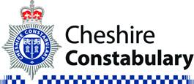](https://www.google.co.uk/url?sa=i&rct=j&q=&esrc=s&source=images&cd=&cad=rja&uact=8&ved=0ahUKEwjbiMXpg7jTAhVGVRQKHbjfDIwQjRwIBw&url=https://www.police.uk/cheshire/&psig=AFQjCNEzLSWuiO71wfrF4W0Hnf5z_Cq86A&ust=1492949335238221)

**Upton Police Update May**

**PCSO George 22696**

[**Beth.george@cheshire.police.uk**](mailto:Beth.george@cheshire.police.uk)

Please refer to the Cheshire Police website for crime statistics for the Upton area -

[Upton | Police.uk (www.police.uk)](https://www.police.uk/pu/your-area/cheshire-constabulary/upton/)

(Please note The Countess of Chester Hospital is included in Upton statistics)

If there is anything specific that needs sharing with the community then I will highlight this separately going forward.

**June surgery dates –**

**9/6/22 – 3-4pm Upton Pavilion**

**14/6/22 9-10am Spar Shops Long Lane**

**20/6/22 – 6-7pm online surgery**

**27/6/22 10-11am Upton Pavilion**

**Speed engagement completed –**

3/5/2022-SID Wealstone Road

3/5/2022-SID St James Avenue

4/5/2022-SID Upton Lane

5/5/20200 – Enforcement Upton Lane

10/5/2022 – Upton Lane with Upton Heath JSO’s

27/5/2022 – Enforcement Upton Lane

**I** **attend locations based on community feedback. Please feedback areas of concern.**

 **15/05/2022 Kits distributed to Marlow Avenue.**

**Residents Voice -** It is important to us that we know about the issues that cause you concern. We have set up a survey where you can tell us about the things you would like us to focus on in your area.

Please complete the survey by following this link - [Resident's voice | Cheshire Constabulary](https://www.cheshire.police.uk/residentsvoicechester)

**A snap shot of the month –**

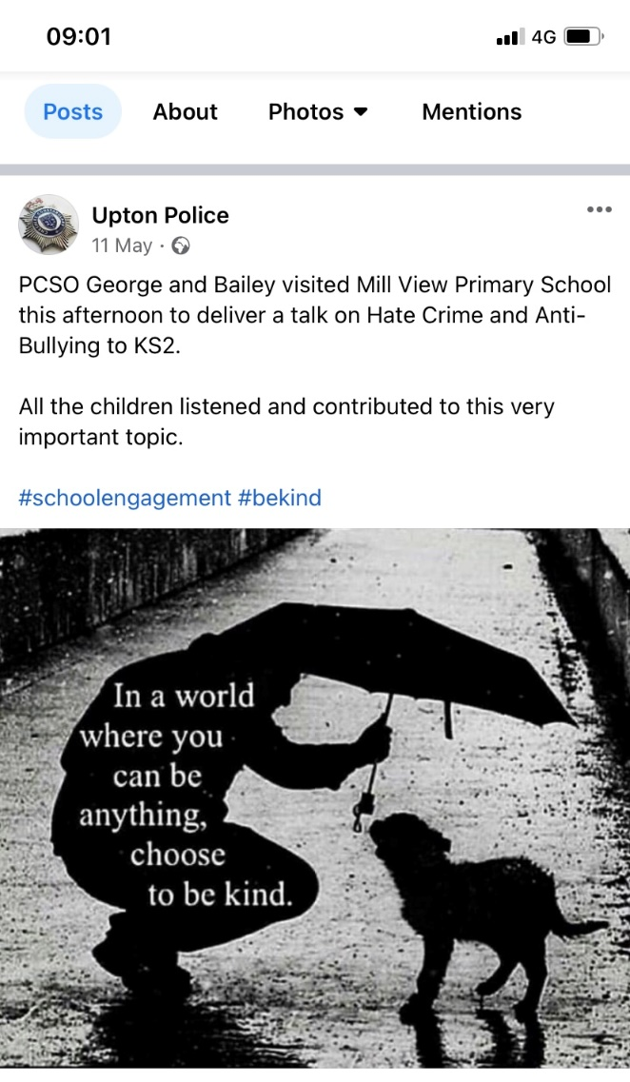

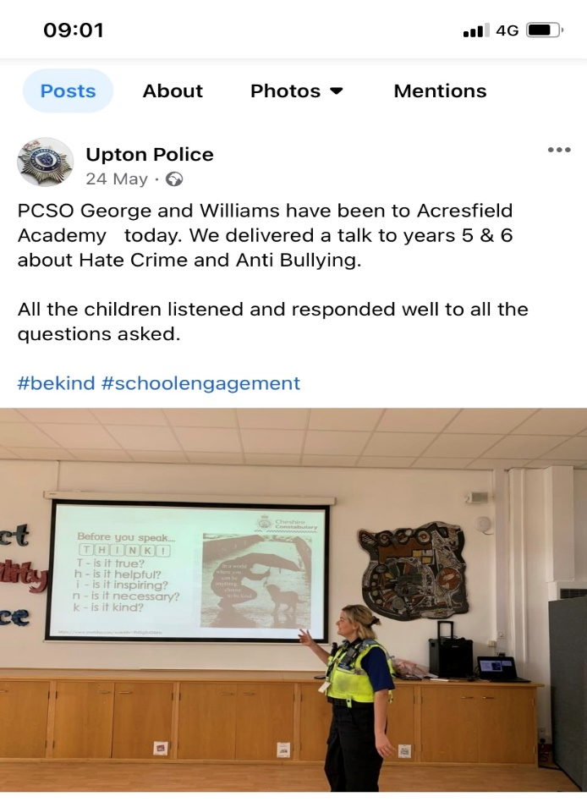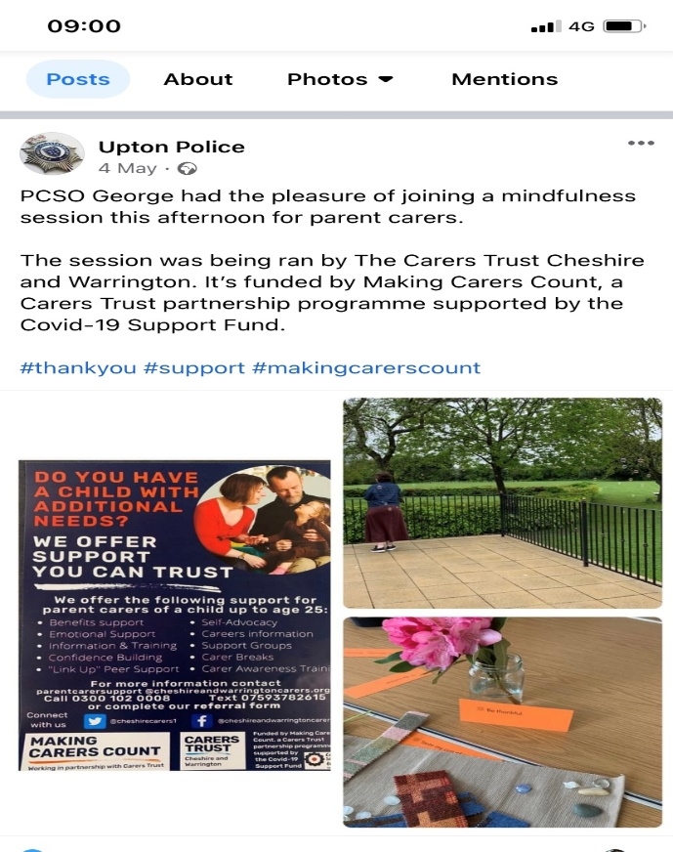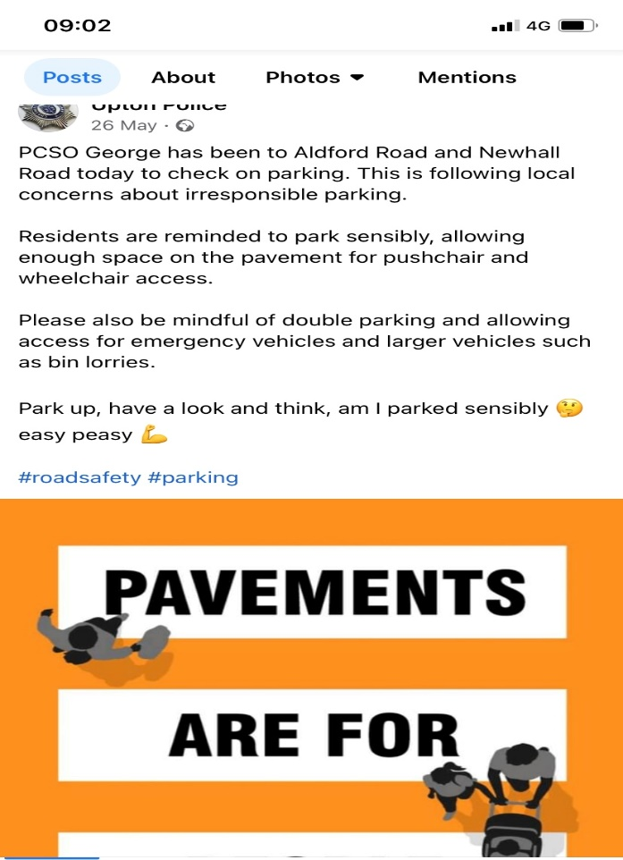

Follow the **Upton Police** Facebook page for regular updates.

Please be aware it is not monitored 24/7 and it should not be used as a reporting tool. 101 or 99 in an emergency.