UPTON BY CHESTER AND DISTRICT
PARISH COUNCIL

18 Gladstone Road
Chester
CH1 4BY
07584415343
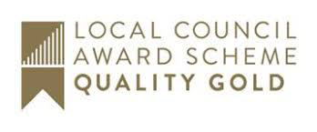
Email: clerk@uptonbychester.org.uk

Minutes of the Meeting of Upton by Chester and District Parish Council Finance Committee held on 02 November 2020, 7.45pm, via Cisco Webex.
Present: Cllr A Bennion, Cllr T Egerton-Parry (Chairman), Cllr J Evans,
Cllr P Greenhalgh, Cllr J Houlbrook and Cllr N Poulton.
In attendance: Ms S Bull (Clerk and Proper Officer).

1. APOLOGIES FOR ABSENCE.
No apologies for absence were received. All present.

2. DECLARATIONS OF INTEREST.
No declarations of interest were made.

3. MINUTES.
Resolved: The Minutes of the meeting held on 5 October 2020 were approved. Proposed by Cllr Greenhalgh, seconded by Cllr Houlbrook.

4. CLERK’S REPORT.
Resolved: The Clerk’s Report was received and noted.

5. BUDGET MONITORING.
Resolved: the new format budget monitoring report was received and noted; it will be provided to this committee monthly.
The £500 Christmas budget will be used to provide additional Christmas trees, with lights in the community.

6. BUDGET 2021/22.
Resolved: The draft budget was received and noted and will be presented to the Full Parish Council at the next meeting.
The clerk will request that the parish tax base information is made available at the earliest opportunity.

5. DATE AND TIME OF THE NEXT MEETING.
Resolved: that where possible Finance Committee meetings will take place on the second Monday of the month.
The date and time of the next meeting will be on Monday 14 December at 7.30pm.

