In this edition:

Winter Advice

Planning

Pavilion News



Upton by Chester & District Parish Council

COMMUNITY NEWSLETTER

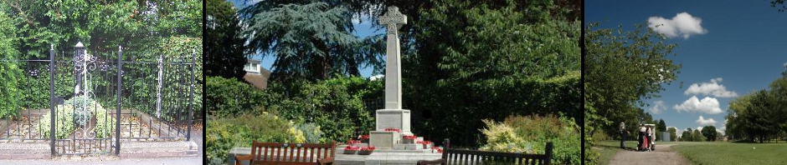

**AUTUMN 2017**

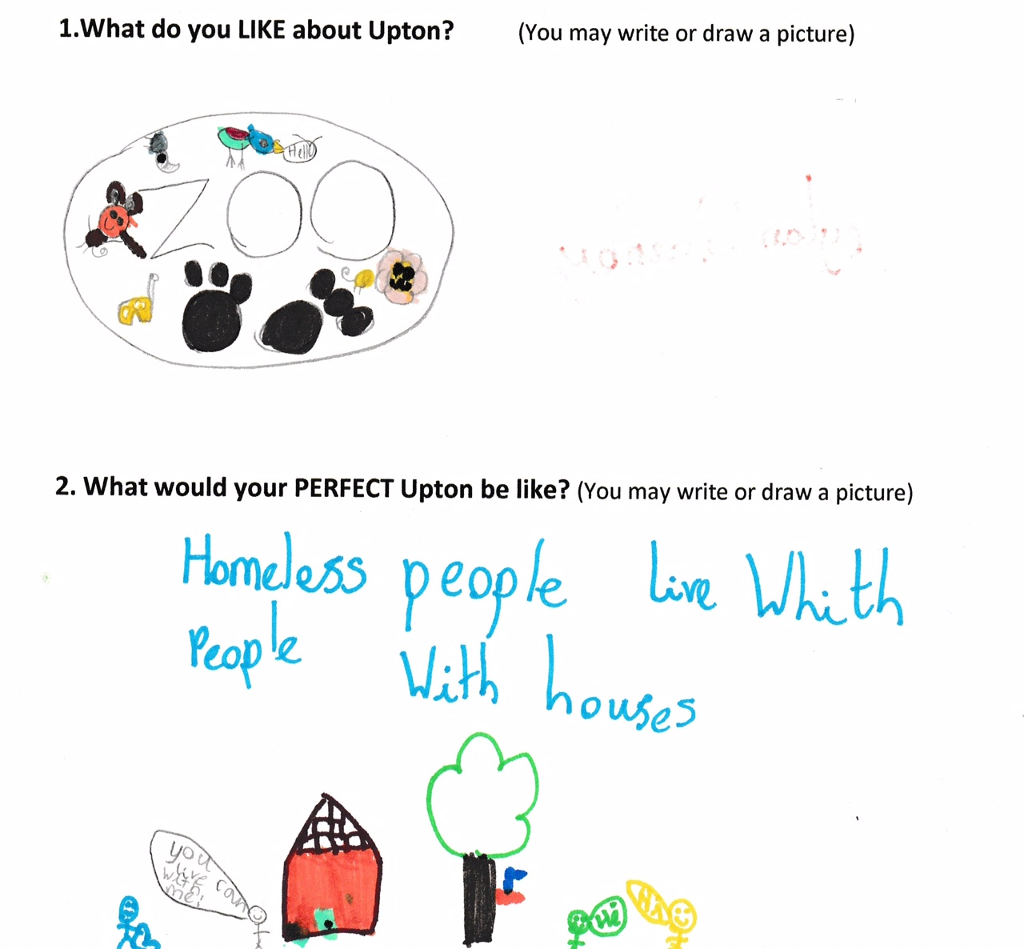

**WHAT WILL UPTON BE LIKE IN 2030?**

HAVE YOUR SAY ON THE FUTURE OF UPTON.

Upton Parish Council and local residents are currently preparing a Neighbourhood Development Plan for Upton, which gives us the chance to make decisions about future planning in our area that will have legal power, such as:

* The allocation of sites for development
* Deciding which facilities are appropriate for a new development or for one that can be improved
* Planning for the development of our open spaces
* Pedestrian and cycle links
* Protecting what we already have, especially our heritage

Plans for our NDP are already being consulted on, we will continue consulting you until the plan is complete, when you will be able to vote on it. If more than 50% of those who vote are in favour of adopting the plan, it will become law.

The more you tell us what you want to happen in your community, the more the plan will reflect the wishes of residents, please let us know if you would like your group or organisation to be given a more detailed presentation, including a video of our area now, to help suggest where to go next and which aspects of Upton we are happy with as they are.

We are consulting:

* People of all ages, including working with schools, since the students of today are the residents of the future
* Major employers in Upton, including Chester Zoo, The Countess of Chester Hospital and The Dale Camp.
* Businesses and organisations in Upton.

As the consultation continues the plan will be amended and adjusted to reflect the feedback given.

Some things we cannot do:

* Alter the Green Belt or boundaries.
* Change national policies, eg on minerals or waste issues.
* Influence public transport or traffic management.

However, the community working together can still be a powerful voice in highlighting the way our neighbourhood would suffer from some of the statutory policies e.g. by pointing out the adverse effect of heavy lorries on our roads or potential damage to the water system, aspects that may be consequences of fracking and may be unwelcome to most of the local community, as well as to our world class zoo. So, even aspects we cannot control, we can have some important influence on by getting through our Neighbourhood Plan.



**UGE POLICY**

On 19th June 2017 the Parish Council formally approved its policy towards Unconventional Gas Extraction (“fracking”).

July 2015 - the Parish Council resolved to develop a policy for UGE, following concerns about the possibility of UGE development in the parish and the potential impacts.

January 2016 - a working party was set up.

March 2016 - a draft policy was written and considered by the working party.

April 2016 - the draft policy was approved unanimously by the Parish Council.

June 2016 - consultation with neighbouring Parish Councils.

September 2016 - draft policy sent to the leader of CW&C Council for comments.

April 2017 - consultation with Upton by Chester residents (a letter to every household, public consultation results: 45 responses, all but 1 in support of the draft policy).

May 2017 - comments or questions raised via the consultation sent to the Planning Authority for clarification.

June 2017 - response received from the Planning Authority.

June 2017 - UGE policy approved by the Parish Council.

**WINTER ADVICE COLUMN**

**Have your heating system serviced each year by a qualified engineer.**

**Never block air vents and if you have wood-burning, coal or gas heaters make sure there is adequate ventilation.**

**If water pipes freeze they can burst. Make sure you know where the main stopcock is and check that it is easy to turn so you can turn off the water if you need to.**

**Have your electric blanket serviced at least every three years.**

**Make sure your smoke alarm is working. You can ask your local fire service to check your home for fire safety. Its free and you may be eligible to get free smoke alarms fitted.**

**Install an audible carbon monoxide alarm in each room that has a gas appliance.**

**Make sure you claim all the financial support you can to help with heating bills.**

**Dress in plenty of layers and make sure you have warm shoes or boots with non-slip soles.**

**Keep a mixture of salt and sand handy to put on steps or paths in icy weather.**

**Consider fitting a grab rail if you have steps at your front or back door.**

**Keep simple cold, flu and sore throat remedies in the house.**

**Have a flu jab.**

**Order repeat prescriptions in plenty of time.**

**Ask your local pharmacy if they offer a prescription pick-up and delivery service.**

**Keep basic food items in the cupboard or freezer; you could also do your food shopping online and have it delivered to your door.**

**Eat healthily and keep as active as possible.**

**Ask family and friends to visit more often.**

**Keep a torch handy in case you lose power, keep your mobile phoned fully charged.**

**If there is a power cut, call 105 for free, you'll be put through to your local network operator who can give you help and advice.**

**Keep a list of emergency numbers, such as your utility companies, by your phone.**

**National Grid Gas 0800 111 999**

**SP Energy Networks 0800 001 5400**

**United Utilities 0800 330 033**

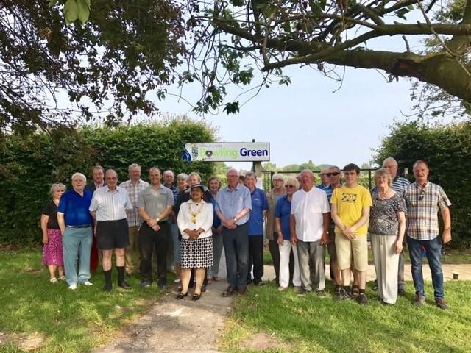

**BOWLING GREEN GRAND RE-OPENING**

Earlier this year we were delighted to invite the Lord Mayor to formally open the newly refurbished Upton Bowling Green.

The Parish Council identified several important projects for the year and with funds set aside from savings the bowling green project was given the go ahead.

As well as a new bowling pavilion, the entire perimeter path was repaired and resurfaced, new back boards were installed and the ditch re-established and sanded.

The unstable garden border wall was partly re-built to create a wonderful seating area.

Our excellent groundsmen continue to spend much time bringing the green up to a better standard.

UPTON CHRISTMAS CELEBRATIONS

13 DECEMBER 2017

UPTON ANNUAL ASSEMBLY

23 APRIL 2018

UPTON PAVILION FUN DAY

15 SEPTEMBER 2018

**SAVE THE DATE**

**PLANNING IN UPTON**

Your Parish Council has now changed how it responds to planning applications affecting the Upton community. Rather than looking at each and every application, including minor ones such as routine house extensions, every Councillor is sent notification and has the opportunity to pass comment but the Parish Council as a whole only tends to look at major and/or controversial planning proposals.

Some recent examples of these are the proposed Aldi Supermarket on Countess Way/Parkgate Road and the housing development planned for Heath Lane (the Parish Council strongly opposing both applications). The Aldi application has yet to be determined but the objections to the Heath Lane application were upheld by the Planning Authority.

**WAR MEMORIAL**

The Parish Council applied for a grant from the War Memorials Trust to refurbish the Upton memorial and surrounds. Unfortunately the WMT did not on this occasion award a grant. This was because memorials elsewhere were considered more in need of attention than ours. However, our application has been resubmitted for consideration in the next grant funding round.

Thank you to Morrisons supermarket, the British Legion and B&Q for providing plants and to the Councillors who regularly care for and maintain the War Memorial garden

**CHESHIRE FIRE SERVICE IN THE COMMUNITY**

The Chester Fire Service now offers a Safe and Well service. Someone from the service will call at your home to give advice on smoke alarms, carbon monoxide devices and checking that fire extinguishers are in date and active.

They also give advice on bowel screening, stroke, prevention of falls and advice on how to stop smoking.

To book this service visit www.cheshirefire.gov.uk

Or call 0800 389053.

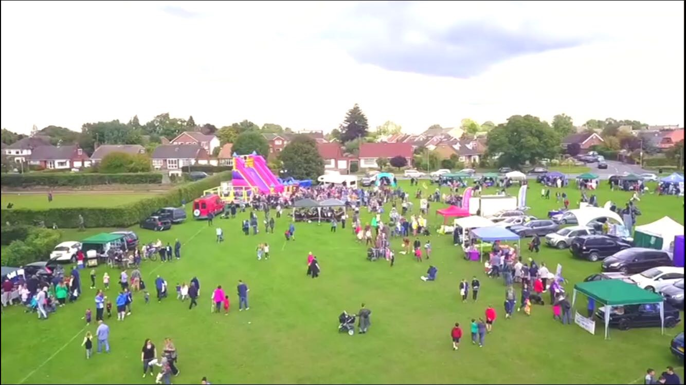

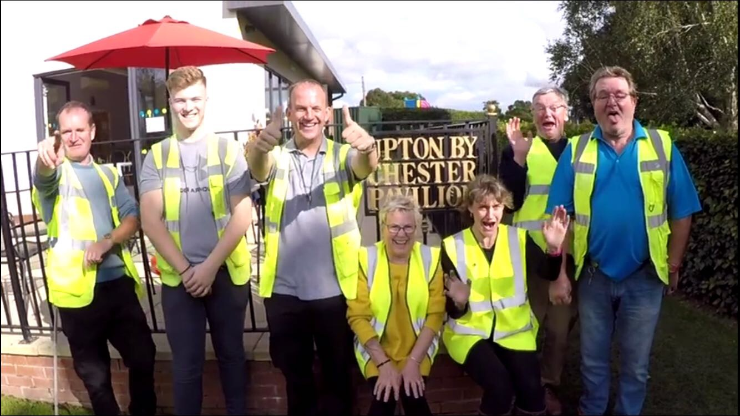

**UPTON PAVILION NEWS**

Thank you for attending the 2017 Upton Pavilion Fun day, it was a great day, very well attended and we have had some fantastic feedback. Grateful thanks to everyone who helped to make this a special day – next one, Saturday 15th September. We now have a small meeting room available at the Pavilion, for up to 8 people.

The Function Room and Meeting Room are available for regular or one off bookings for your club, group or business, from £10 per hour.

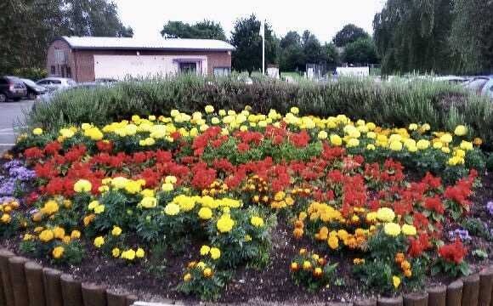

**SUMMER FLORAL DISPLAY**

Thank you to Upton Pavilion staff member Pete Griffiths for designing and planting our lovely summer floral display. Spring bulbs will be planted shortly to provide a wonderful display early next year.

**YOUR PARISH COUNCILLORS:**

**BACHE**

Cllr Frank Samuel, 01244 382673.

[Frank.samuel@uptonbychester.org.uk](mailto:Frank.samuel@uptonbychester.org.uk)

**MOSTON**

Cllr Kate Vaughan, 07738 184089.

[Kate.vaughan@uptonbychester.org.uk](mailto:Kate.vaughan@uptonbychester.org.uk)

**UPTON GRANGE**

Cllr Matt Bryan, 07982 090451.

[Matt.bryan@uptonbychester.org.uk](mailto:Matt.bryan@uptonbychester.org.uk)

Cllr David Ford, 07975 726797.

[David.Ford@uptonbychester.org.uk](mailto:David.Ford@uptonbychester.org.uk)

Cllr Jill Houlbrook, 01244 344318.

[Jill.houlbrook@cheshirewestandchester.gov.uk](mailto:Jill.houlbrook@cheshirewestandchester.gov.uk)

Cllr Hilarie McNae, 01244 380433.

[Hilarie.mcnae@uptonbychester.org.uk](mailto:Hilarie.mcnae@uptonbychester.org.uk)

Cllr Stuart Lloyd, 01244 383811

[Stuart.lloyd@uptonbychester.org.uk](mailto:Stuart.lloyd@uptonbychester.org.uk)

Cllr Brenda Southward, 01244 380654.

[Brenda.southward@uptonbychester.org.uk](mailto:Brenda.southward@uptonbychester.org.uk)

**UPTON HEATH**

Cllr Theresa Bartliff, 01244 348467.

Cllr Alison Bennion, 07984 726878.

[Alison.bennion@uptonbychester.org.uk](mailto:Alison.bennion@uptonbychester.org.uk)

Cllr Simon Eardley, 07738 184101.

[Simon.eardley@uptonbychester.org.uk](mailto:Simon.eardley@uptonbychester.org.uk)

Cllr Jeffrey Lee, 01244 372458.

[Jeffrey.lee@uptonbychester.org.uk](mailto:Jeffrey.lee@uptonbychester.org.uk)

Cllr Mary Lloyd, 01244 383811.

[Mary.lloyd@uptonbychester.org.uk](mailto:Mary.lloyd@uptonbychester.org.uk)

Cllr Alan Paddock, 07836 626638.

[Alan.paddock@uptonbychester.org.uk](mailto:Alan.paddock@uptonbychester.org.uk)

**UPTON PARK**

Cllr Jean Evans, 01244 377200.

[Jean.evans@uptonbychester.org.uk](mailto:Jean.evans@uptonbychester.org.uk)

Cllr Adrian Walmsley (Chairman), 07710 583513.

[Adrian.walmsley@uptonbychester.org.uk](mailto:Adrian.walmsley@uptonbychester.org.uk)

**PAVILION OPENING HOURS:**

Monday – Sunday 9am to 5pm, until 1st April 2018 then, Monday – Sunday 10am to 9pm.

**CONTACT DETAILS:**

For pavilion room hire, playing fields, tennis courts and bowling please call the office on 01244 374054 or email **uptonbychesterpavilion@hotmail.com.**

**……………✂......................................................................................................................................................**

**Upton by Chester Parish Council wants your views on improvements to the Q E II Playing Fields and Playground.**

We are always keen to consult with residents when planning improvements to Parish Council facilities. Do you have any suggestions you would like us to consider when planning improvements and maintenance to the facilities at the QE II Playing Fields and children’s playground? Get in touch by completing this tear off slip and return to: Upton Pavilion, Wealstone Lane, Upton,

CH2 1HB. Alternatively contact the clerk on 07584 415343.

Name

Address

Phone number Email address