UPTON BY CHESTER AND DISTRICT
PARISH COUNCIL

18 Gladstone Road
Chester
CH1 4BY
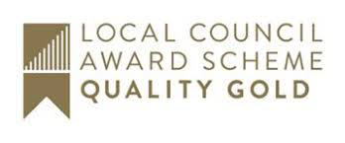
07584415343
Email: clerk@uptonbychester.org.uk

Dear Member,
You are summoned to the Meeting of the Finance Committee to be held at 7.30 pm on Monday 05 October 2020 online, via Cisco Webex (joining details available from the Clerk).

The business to be transacted at the meeting is detailed on the agenda below. Please note that Standing Orders will apply at this meeting. Members of the press and public are entitled to attend and there will be an 'Open Forum' for 10 minutes at the beginning of the meeting to raise any issues with the Parish Council.

Signed Suzi Bull Clerk/ Proper Officer to the Parish Council 28.09.20

AGENDA

1. APOLOGIES FOR ABSENCE.
To receive and note apologies for absence as reported to the clerk.

2. DECLARATIONS OF INTEREST.
Members are invited to declare any interests they may have in any items on this agenda as per the Code of Conduct.

3. MINUTES.
To approve the Minutes of the meeting held on 13 July 2020. Enc

4. BUDGET 2021/22.
- To receive income and expenditure information for 2019/20, also forecast information for 2020/21.
- To consider the budget requirements for the period 2021/22.

5. DATE AND TIME OF THE NEXT MEETING.
To confirm the date and time of the next meeting will be on Monday 2 November.

