UPTON BY CHESTER AND DISTRICT
PARISH COUNCIL

18 Gladstone Road
Chester
CH1 4BY
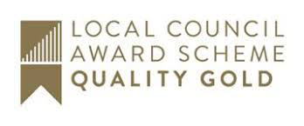
07584415343
Email: clerk@uptonbychester.org.uk

Dear Member,
You are summoned to the Meeting of the Communications Committee to be
held at 7.00 pm on Monday 14 October 2019 at Upton Pavilion, Wealstone Lane, Upton, Chester.
The business to be transacted at the meeting is detailed on the agenda below. Please note that Standing Orders will apply at this meeting. Members of the press and public are entitled to attend and there will be an 'Open Forum' for 10 minutes at the beginning of the meeting to raise any issues with the Parish Council.
Signed: Suzi Bull - Clerk to the Parish Council 09.10.19
AGENDA

1. APOLOGIES FOR ABSENCE.
To receive and note apologies for absence as reported to the clerk.

2. DECLARATIONS OF INTEREST.
Members are invited to declare any interests they may have in any items on this agenda as per the Code of Conduct.

3. MINUTES.
To approve the Minutes of the meeting held on 9 September 2019.

4. DRAFT NEWSLETTER.
To review and approve the draft newsletter.

5. PUBLIC SECTOR WEBSITE ACCESSIBILITY.
To receive information and consider action necessary for compliance.

6. WEBSITE AND SOCIAL MEDIA.
To confirm the date of a meeting to consider improvements to the website and social media platforms.

7. DATE AND TIME OF THE NEXT MEETING.
To confirm that the date and time of the next meeting will be on Monday 6 January 2020.

