UPTON BY CHESTER AND DISTRICT
PARISH COUNCIL

18 Gladstone Road
Chester
CH1 4BY
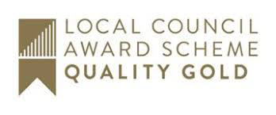
07584415343
Email: clerk@uptonbychester.org.uk

Dear Member,
You are summoned to the Meeting of the Communications Committee to be
held at 6.30 pm on Monday 3 February 2020 at Upton Pavilion, Wealstone Lane, Upton, Chester.
The business to be transacted at the meeting is detailed on the agenda below. Please note that Standing Orders will apply at this meeting. Members of the press and public are entitled to attend and there will be an 'Open Forum' for 10 minutes at the beginning of the meeting to raise any issues with the Parish Council.
Signed: Suzi Bull - Clerk to the Parish Council 29.01.20
AGENDA

1. APOLOGIES FOR ABSENCE.
To receive and note apologies for absence as reported to the clerk.

2. DECLARATIONS OF INTEREST.
Members are invited to declare any interests they may have in any items on this agenda as per the Code of Conduct.

3. MINUTES.
To approve the Minutes of the meeting held on 14 October 2019.

4. COMPLIMENTARY ZOO TICKET.
To review the process of distributing the Upton residents’ complimentary zoo ticket.

5. PRINTING.
To consider printing services.

6. SPRING NEWSLETTER.
To consider articles and layout for the spring newsletter.

7. WEBSITE AND SOCIAL MEDIA.
To review the Parish Council’s website and use of social media.

8. DATE AND TIME OF THE NEXT MEETING.
To confirm that the date and time of the next meeting will be agreed at this meeting.

